Wk11 Writeup

Note: the following is for training on TSC and testing on AAF

# Implemented Threshold + Classification

Looking at one of the problematic edges (WP76_L1), we see the regression approach beats no prior/Length method

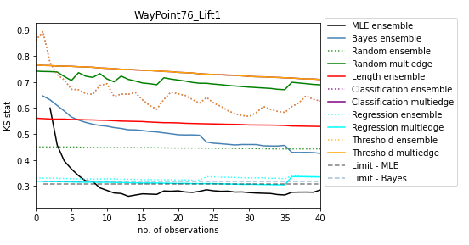

# Compare starting KS for all edges

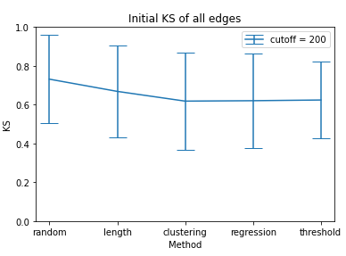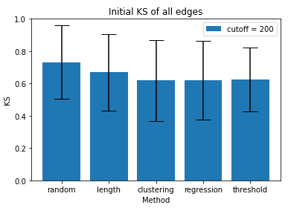

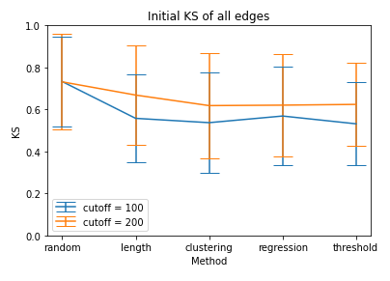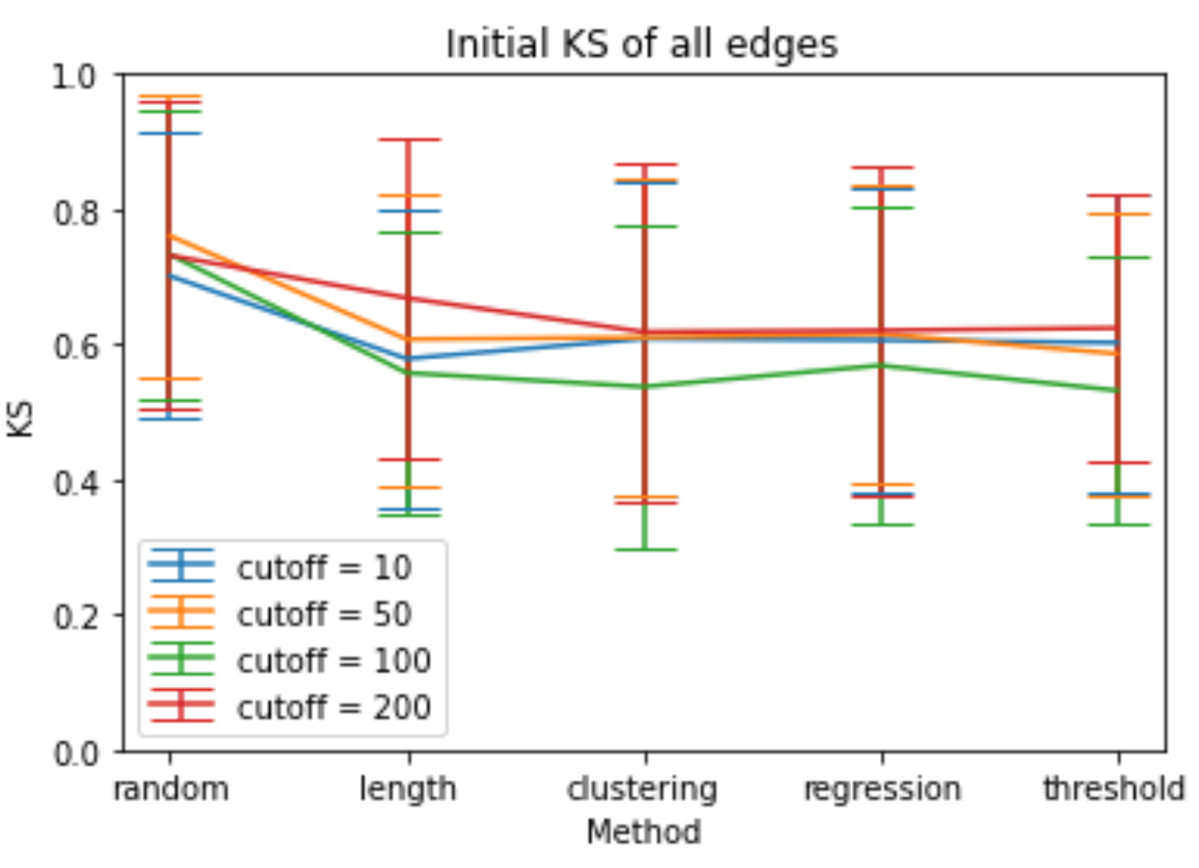

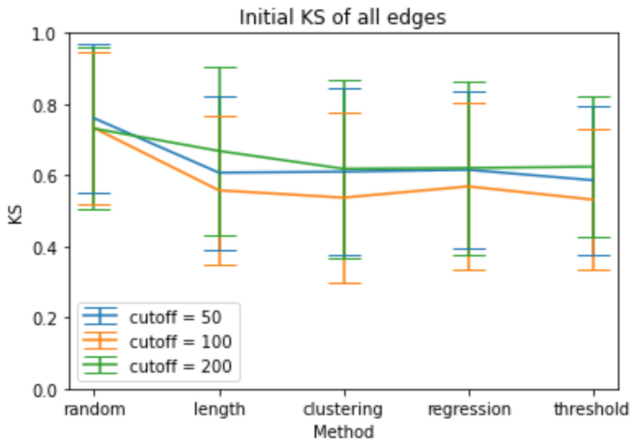

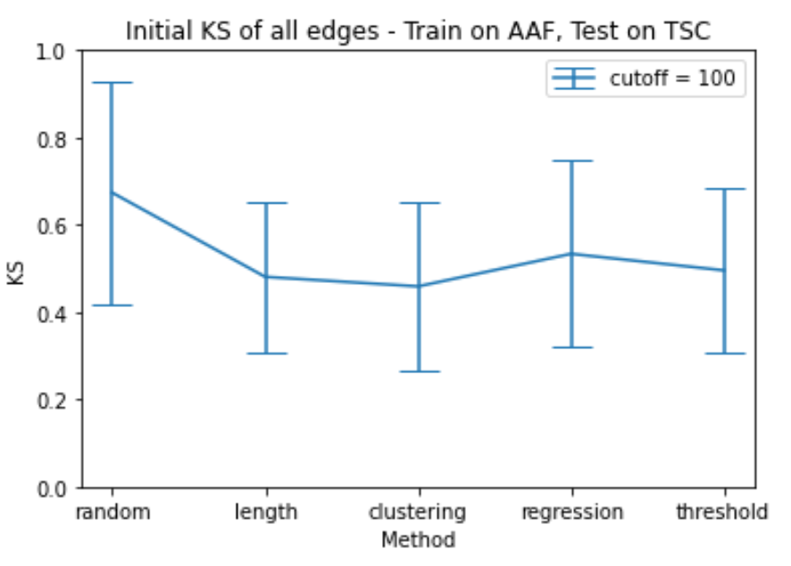

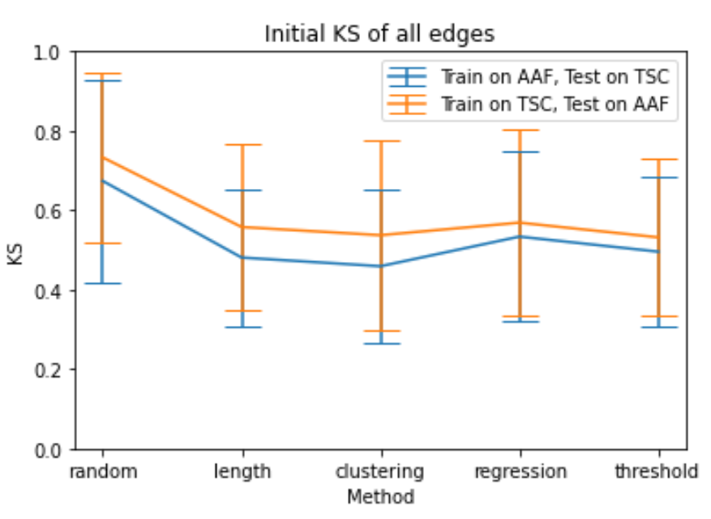

# Starting KS for Specific Map

#### Train on Walmart, Test on Blenheim – no congestion

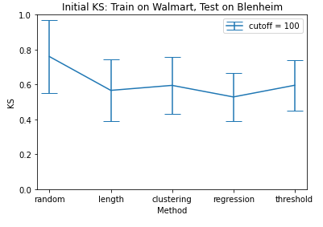

Regression has outperformance, given that Blenheim only has one cluster so classification is not appropriate.

#### Train on Walmart, Test on Blenheim – congested

Any value of n_robots

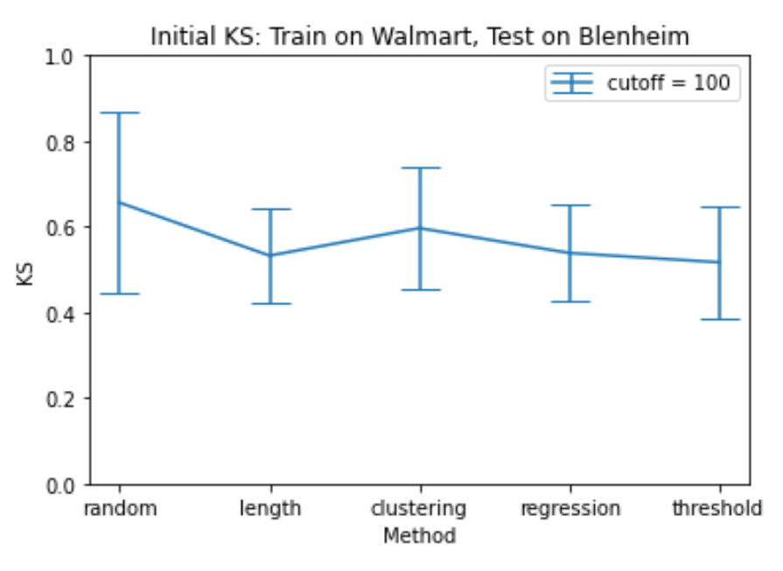

N_robots >= 2

